SMART SURVEYING DEVICE FOR RESOURCE OPTIMIZATION

FRIENDS

BY:

SUSHANTH REDDY.PANTA

SAI MANIKANTA.DESU

KABEER BASHA.SHAIK

PROBLEM STATEMENT:

COUNTING THE NUMBER OF PEOPLE MOVING IN AND OUT IN AN MALL OR IN A OPEN AREA USING OPEN CV.

ABSTRACT:

The detection and counting of people is a method widely used for monitoring and video surveillance. The objective of this project is to perform the counting of people process from flat images, with a camera located on top of an interior environment. The algorithm used for the counting of people process was developed by morphological processes based on flat images, since the camera is on top of an interior environment, the same ones that serve to modify the system behaviour. The counting system is divided into two components; one component is for image monitoring and the other one for image acquisition. The system used for counting people has some conditions that need to be met in order for it to work properly; First of all, it is important to check if the person is in the detection zone; secondly, the system has limits at the top and bottom areas to check if the person enters or leaves the detection zone. The people counting system was coded in Python through the OpenCv library which shows the data coming from the camera, indicating the number of people who entered or left a particular site. The algorithm that was developed for this counting system was evaluated in a classified and registered database.

INTRODUCTION:

Currently the applications that are based on the counting of people are very used for which there is a great demand, due to its system of security and video surveillance that allows to know the amount of people who enter and leave of place cite Head. Some methods for detecting people are based on background subtraction, in the tracking of objects in the foreground is done through the occupation area to differentiate the number of people and a color vector to track each person. Another type of system is where the camera is inclined, these systems need to obtain a perspective of the person to carry out their detection cite doc: Motion. Most systems that perform the counting of people do so with a single camera that is oriented in a zenith and at a certain height. The system has two regions of interest defined at the top and bottom of the image. The histogram of these regions of the motion picture is calculated and by comparing a threshold detect the occupancy level. The bi-directional count is based on a deterministic algorithm that is based on the crossing of the upper and lower regions. This type of system with a zenithic orientation can not perform an analysis of the detected object, since the view does not offer enough characteristics to detect the person.

METHODOLOGY:

* DETECTION OF PEOPLE:

From the contour detection it is determined whether it belongs to people or not, taking into account that it requires detection of target people. First filtering of areas is done, taking into account that areas that are above or below a value are filtered. So much that the main objective is the detection and counting of people in a certain range of distance, and possesses certain limits of major or minor areas. Then the next filter is applied that has to do with the long and wide relation of the person detected, whether it is standing or sitting, if in a case it is required to enter people in a row holding hands would expand the limit already be higher or lower to avoid detection conflicts. Due to the restriction of limits that it possesses it can be limited the detection of objects that have characteristics similar to the person in relation to its width and the proportion of its stop. It is also necessary to take into account in the area of detection that it encompasses the contour of the person and if it does not it would not detect the person or would cause false detections. Another important point is the resolution of the video, since the lower resolution of the video has a better detection and counting compared to high resolutions. With everything mentioned above you get a very good percentage of correct detections, but also you get some margin of error therefore it is not totally reliable. Finally, after explaining how people were detected, it should be emphasized that the program is designated to the count of a single person and the process consists of detecting the person’s position and locating each frame of the person. On the other hand, when there is more than one person in the detection area, the program can not detect x people in x positions

VIDEO OUTPUT:

This section is the one that deals with the generation of the output video, being the final result of the application. The output video is constantly executed and it shows each result at the moment of its operation. This process starts in the obtaining of images by means of a camcorder, that step is simple since it is realized automatically. The application consists of two windows, the first window shows the input image either in the form of recorded video or in real time, taking into account that the detection area encompasses the person detected in each position. When having the window in which the entry and exit of people is visualized, the moment in which the person is detected is observed and when the limits are passed, the count is higher or lower, this is done to improve the visualization of the user. It is done in order for the user to visualize their area of video surveillance and is aware of what happens at that time and how the algorithm behaves in environments and internal scenes. The number of people detected at each instant, both incoming and outgoing, is displayed in the same way, the information is stored and then used as desired by the user. Finally, it can also be observed in the second window when the morphological filter is applied, with this the person can have evidence of what happens in the application and if the detection and counting of people is accurate or not.

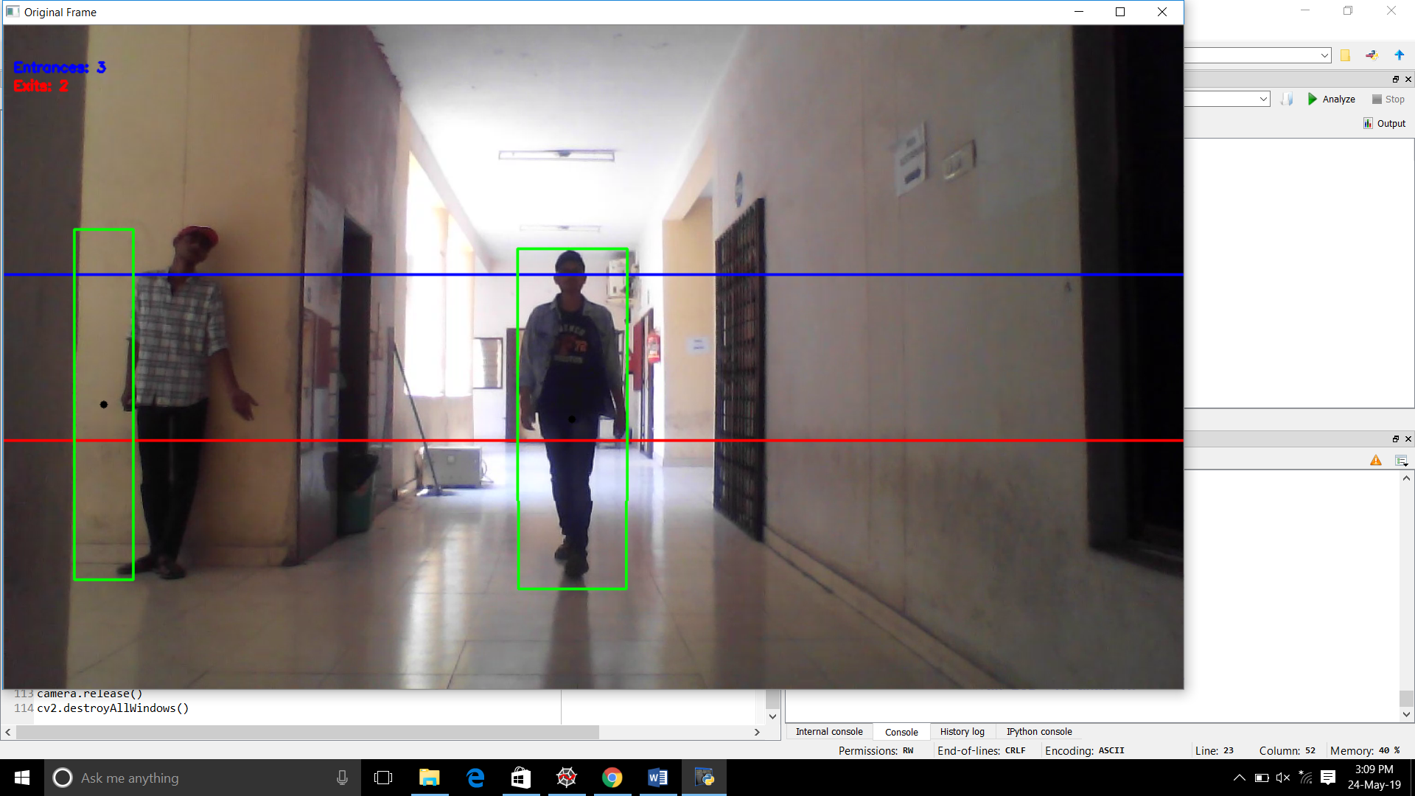

LIBRARIES AND HEADER FILES USED:

* IMPORT CV2
* IMPORT NUMPY
* CV2.VIDEO CAPTURE:

OPEN CV PROVIDES A VERY SIMPLE INTERFACE FOR CAPTURING LIVESTREAM.

* CAMERA.SET:

IT WILL SET THE CAMERA PARAMETERS IN OPENCV

* CAMERA READ:

IT WILL READ AND DISPLAY THE VIDEO.

* CV2.CVTCOLOUR:

CONVERTS AN IMAGE FROM ONE COLOUR SPACE TO ANOTHER.

* CV2.GAUSSIANBLUR:

IT IS HIGHLY EFFECTIVE IN REMOVING NOICE FROM THE IMAGE AND IT DEPENDS ON STANDARD DEVIATION IN (X ,Y) DIRECTION.

* CV2.ABSDIFF:

IT GIVES FAST AND ERROR DEPENDENT RESULT ON CHECK DIFFERENT PACEMENT VECTORS WITH TWO IMAGES IT WOULD BE FINE TO ELIMINATE THIS MEMORY ALLOCATION.

# Learning Resources:

<https://www.pyimagesearch.com/>

<https://github.com/LukashenkoEvgeniy/People-Counter>

CONCLUSION:

The application presents an autonomous operation since the user at no time manipulates variables during the execution of the application. It also has a low cost in the acquisition stage, and it was demonstrated that using a low quality camera the system has a good operation, and the acquisition of images is done in real time and through previously recorded videos, it is better perform it in real time to avoid loss of information and false detections.

REFERENCES:

* S. S. Sumati Manchanda, “Analysis of Computer Vision based Technique

for Motion Detection”, Jun. 2016.

* ] D. Lefloch, “Real-Time People Counting system using Video Camera”. Jan, 2007.